

Symbiosis
Institue of technology
(Established under section 3 of the UGC Act 1956)
Re-accredited by NAAC with “A” Grade

Name of the Student: Aniruddha Pratap Singh PRN: 25070122247
Semester: 3 Year: AY 25-29

ASSIGNMENT No: 3

TITLE: Develop a Java application demonstrating method overloading and the use of static variables, methods in class design.

Problem Statement: Develop a Java application demonstrating method overloading and the use of static variables, methods in class design.

Exercise 3.1 - Develop a Calculator program using overloaded methods for addition of integers and decimals. Use a static variable to count calculations.

Program –
class Calculator {

// Static variable
static int totalCalculations = 0;

// Constructor
Calculator() {
totalCalculations++;
}

// Overloaded methods
int add(int x, int y) {
return x + y;
}

double add(double x, double y) {
return x + y;
}

int add(int x, int y, int z) {
return x + y + z;
}

// Static method
static void showCount() {
System.out.println("Total Calculator Objects: " + totalCalculations);
}

public static void main(String[] args) {

Calculator calc1 = new Calculator();
Calculator calc2 = new Calculator();

System.out.println("Sum of two integers : " + calc1.add(15, 25));
System.out.println("Sum of two decimals : " + calc1.add(12.5, 18.5));
System.out.println("Sum of three integers : " + calc1.add(10, 20, 30));

showCount();
}
}

Output :
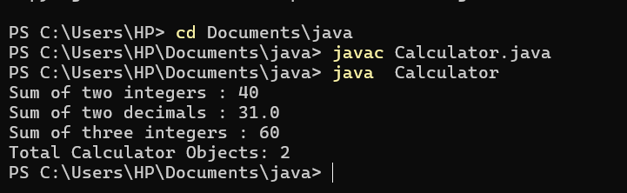

EXERCISE 3.2 : Develop a Restaurant Billing Application where overloaded methods calculate bills for dine-in, takeaway, and delivery orders, while static variables track total orders.

Program –
class Calculator {

// Static variable

static int totalCalculations = 0;

// Constructor
Calculator() {
totalCalculations++;
}

// Overloaded methods
int add(int x, int y) {
return x + y;
}

double add(double x, double y) {
return x + y;
}

int add(int x, int y, int z) {
return x + y + z;
}

// Static method
static void showCount() {
System.out.println("Total Calculator Objects: " + totalCalculations);
}

public static void main(String[] args) {

Calculator calc1 = new Calculator();
Calculator calc2 = new Calculator();

System.out.println("Sum of two integers : " + calc1.add(15, 25));
System.out.println("Sum of two decimals : " + calc1.add(12.5, 18.5));
System.out.println("Sum of three integers : " + calc1.add(10, 20, 30));

showCount();
}
}

Output :
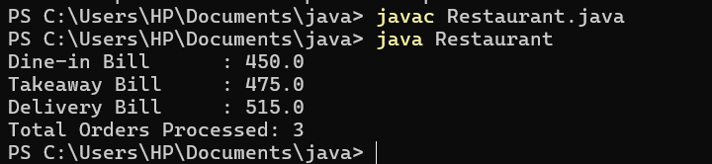

Conclusion : This assignment demonstrated the implementation of method overloading and the use of static variables and static methods in Java. Method overloading allowed the same method to perform different operations based on different parameter lists, while static members were used to share common data among all objects. The assignment improved the understanding of code reusability, flexibility, and efficient class design in object-oriented programming

